INTRODUCTION

  - ABOUT THE PROJECT

The “School Record Platform" is prepared or operates to maintain the records of student in school. School Record Platform deals with the all the activities done by computers such as registration admission process online, and staff and class management etc. all these process are handled by the computer management system. The student record can be maintained online for the distance accessible to the entire student and their parents. Without the student management system managing and maintaining the details student is tedious job for any organization.
School Record Platform will store all the detailed of the students including their background information, educational qualifications, Personal details and all the information related to their resume. Suppose we have 1000 of student from this we have to search a particular student we know the name of the student. In a manual system it is a tedious task through we know the name of student but using the module we can easily search the student by specifying the name of student in the search criteria. Thusmodule will help the administrator in searching the student with the various criteria.
The project SchoolRecord Platformhas been developed with Visual Basic 6.0as Front-End application and MS Access as Back-End source. The following are the main modules of this project:
- Login and User Authentication Module
- Student Registration and Data Entry Module
- Student Information Management Module
- Academic Records and Performance Module
- Attendance Tracking Module
- Course Enrollment and Management Module
- Search and Filter Module
- Reporting Module
- Database Management Module
- Admin and Settings Module

SCOPE OF THE PROJECT

The scope of the Student Record Platform project is to provide an automated, efficient, and user-friendly system for managing student information in educational institutions. This project covers the entire lifecycle of student data management, from registration and course enrollment to tracking academic performance, attendance, and generating detailed reports. The platform is designed to replace manual record-keeping processes, ensuring accuracy, security, and easy access to student information. By integrating features such as role-based user access, search and filter capabilities, and data reporting, the system aims to streamline administrative tasks, improve decision-making, and enhance communication between faculty, administrators, and students. The project is intended to be scalable, allowing for future enhancements, such as the addition of online access or integration with other institutional systems.

1.3 OBJECTIVES OF THE PROJECT
The objectives of the Student Record Platform project are as follows:
- Efficient Data Management
- Automation of Administrative Tasks
- User-Friendly Interface
- Role-Based Access Control
- Accurate Reporting
- Data Security and Integrity
- Scalability and Flexibility
- Search and Filter Functionality
- Cost-Effective Solution
- Improved Decision Making

  - STATEMENT OF THE PROBLEM
The problem addressed by the Student Record Platform is the inefficiency and error-prone nature of traditional manual student record-keeping systems used in educational institutions. Many schools and colleges still rely on paper-based or spreadsheet systems to manage student data, leading to challenges such as data loss, difficulty in accessing information quickly, limited reporting capabilities, and difficulty in tracking performance over time. Furthermore, manual systems are prone to human error and are time-consuming for both administrators and faculty members. As educational institutions grow, the complexity of managing increasing amounts of student data becomes overwhelming, making it difficult to maintain accuracy, ensure security, and provide timely access to critical information. The lack of an integrated, automated solution hampers decision-making, reduces efficiency, and increases administrative overhead. This project aims to solve these issues by providing a digital, centralized platform to streamline the management, retrieval, and reporting of student records, improving the overall efficiency and effectiveness of educational institutions.
1.5 FEASIBILITY STUDY

1. Technical Feasibility

The Student Record Platform project is technically feasible given the existing resources and technologies available. The system is designed using Visual Basic (VB) for the front-end development, which is a widely-used programming language with a rich set of development tools and libraries. MS Access serves as the back-end database, which is a reliable, cost-effective database management system for small to medium-sized applications. Both VB and MS Access are widely supported and easy to implement, even by developers with basic technical knowledge. Additionally, there is no need for complex infrastructure or hardware upgrades, making it technically feasible for most educational institutions to implement.

2. Financial Feasibility

The project is financially feasible for educational institutions with a limited budget. The use of free or low-cost tools, such as Microsoft Access (which is often bundled with Microsoft Office) and Visual Basic (available in Visual Studio), significantly reduces development costs. Furthermore, there are no high infrastructure or ongoing maintenance costs involved in the project. Educational institutions can implement the system with minimal investment, and the long-term cost savings in administrative time and data management will outweigh the initial development cost. The system will also reduce the need for paper-based records, thus contributing to cost savings in the long run.

3. Operational Feasibility

Operationally, the Student Record Platform is highly feasible, as it addresses the operational inefficiencies of manual record-keeping. The platform is designed to simplify the process of managing student records, tracking performance, and generating reports, leading to improved productivity for administrative staff and faculty. The system's user-friendly interface ensures that staff with minimal technical knowledge can effectively use the platform. Additionally, the platform's role-based access control ensures proper security and user management, which is vital for smooth operations within educational institutions.

4. Regulatory Feasibility

The platform adheres to standard regulations surrounding data security, privacy, and confidentiality in educational institutions. By incorporating role-based access controls and data encryption techniques, the system ensures compliance with data protection laws such as GDPR (General Data Protection Regulation) or FERPA (Family Educational Rights and Privacy Act), depending on the jurisdiction. Educational institutions can set permissions for different users, ensuring sensitive information is only accessible to authorized individuals. Furthermore, regular backups can be performed to prevent data loss, which is crucial for maintaining compliance with regulatory standards.

5. Market Feasibility

The market for the Student Record Platform is highly feasible, as many educational institutions are looking for ways to digitize and automate their administrative processes. With the growing trend towards digital transformation in education, there is a significant demand for solutions that streamline administrative tasks and improve the accessibility and management of student data. Smaller schools, colleges, and universities that lack resources for complex systems can benefit from an affordable and easy-to-implement solution like the Student Record Platform. As such, the platform has strong market potential within the education sector, especially in regions where the adoption of digital tools in educational institutions is increasing.
- PROFILE OF THE STUDY
  - ORGANIZATION PROFILE
Company Name: StudentTrack Systems
Industry: EdTech / Student Information Systems
Founded: 2012
Headquarters: 128 Academic Drive, Knowledge Park, 67890
About the Company:
StudentTrack Systems is a pioneering company specializing in Student Information Management and Record-Keeping solutions for educational institutions. With over a decade of experience in the education technology industry, StudentTrack Systems is committed to simplifying the management of student data through innovative, secure, and user-friendly platforms.
The company’s flagship product, StudentTrack, is a comprehensive student records platform designed to store, manage, and analyze student data. It allows schools, colleges, and universities to efficiently handle student enrollment, academic records, grades, attendance, transcripts, and more. The platform is cloud-based, ensuring data security and easy access for both educators and administrators, and integrates seamlessly with other educational tools.
Key Products & Services:
- Student Information System (SIS)
- Academic Record Management
- Student Enrollment and Registration
- Grade and Transcript Management
- Attendance Tracking
- Compliance and Reporting
- Mobile App Integration
- Data Security and Backup
- Parent and Student Portal
Mission:
StudentTrack Systems strives to empower educational institutions with reliable, efficient, and scalable solutions to manage student data, streamline administrative tasks, and improve the overall educational experience.

  - ORGANIZATION CHART
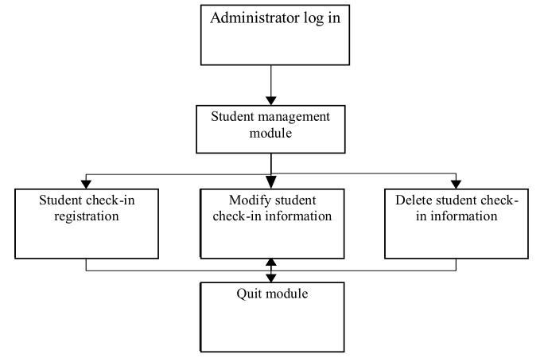

- SYSTEM ANALYSIS AND DESIGN

  - EXISTING SYSTEM
The existing system for managing student records in many educational institutions is often based on manual processes or outdated software solutions. These systems typically involve maintaining paper records or using spreadsheets to store and manage student information, which can be time-consuming, error-prone, and difficult to maintain. In some cases, institutions may use legacy database systems or standalone applications that lack integration, resulting in fragmented data storage and inefficient data retrieval. This leads to challenges such as difficulty in generating reports, limited search and filtering capabilities, security risks, and the possibility of data loss. Furthermore, the manual entry of student data increases the likelihood of mistakes, and updates to student records often require significant administrative effort. The existing systems also struggle to keep pace with the increasing volume of student data as institutions grow, making it harder to ensure data accuracy, consistency, and timely access. As a result, the need for a more automated, centralized, and reliable solution, like the Student Record Platform, becomes crucial to address these operational inefficiencies.
    - DRAWBACKS
Here are the drawbacks of the existing system for managing student records:
- Manual Data Entry: The reliance on manual data entry increases the chances of human error, leading to inaccurate or incomplete records, which can cause operational problems.
- Time-Consuming: Managing student records manually or using spreadsheets is time-intensive, especially when dealing with large amounts of data, making administrative processes slower and less efficient.
- Limited Reporting and Analysis: Existing systems often lack advanced reporting capabilities, making it difficult to generate comprehensive reports or analyze student performance and attendance effectively.
- Data Security Risks: Paper-based records or poorly secured digital files expose sensitive student information to security risks, such as unauthorized access or data loss.

  - PROPOSED SYSTEM
The proposed system, the Student Record Platform, aims to address the limitations of the existing manual or outdated systems by providing an integrated, automated solution for managing student records. This platform will streamline the process of storing, updating, and retrieving student information, including personal details, academic performance, attendance, and course enrollment. With a user-friendly interface built in Visual Basic (VB) and a reliable backend using MS Access, the system will automate administrative tasks such as data entry, report generation, and attendance tracking. It will feature role-based access control to ensure data security and privacy, allowing only authorized users to access sensitive information. Additionally, the system will provide advanced search, filter, and reporting capabilities to allow quick retrieval of student records and the generation of detailed performance reports. By eliminating manual record-keeping and reducing administrative overhead, the proposed system will enhance operational efficiency, improve data accuracy, and support better decision-making in educational institutions.

  - DESCRIPTION OF MODULES

1. User Management Module
- User authentication (login/logout)
- Role-based access control (Admin, Technician, Inventory Manager)
- Password management and profile settings
2. Inventory Management Module
- Add, update, and delete spare parts & tools
- Track stock levels and low-stock alerts
- Barcode scanning for quick item identification
- Supplier details and stock purchase records
3. Service Request & Work Order Module
- Create and manage service requests
- Assign service tasks to technicians
- Track work progress and completion status
- Service history and records for each customer
4. Customer & Supplier Management Module
- Store customer details and service history
- Manage supplier information and purchase orders
- Track payment history and outstanding dues
5. Billing & Invoice Module
- Generate invoices for completed services
- Apply labor charges and spare part costs
- Payment tracking (paid, pending, overdue)
- Print and export invoices in PDF format
6. Reporting & Analytics Module
- Inventory usage reports and stock movement analysis
- Service performance and technician efficiency reports
- Revenue and expense tracking
- Monthly and yearly service trends

  - SYSTEM SPECIFICATION

    - HARDWARE CONFIGURATION

PROCESSOR : i3 Processor 5th GENERATION

HARD DISK : 1 TB

MOUSE : OPTICAL MOUSE

KEYBOARD : 104 STANDARD KEYBOARD

RAM : 8 GB DDR4

    - SOFTWARE SPECIFICATION

OPERATING SYSTEM : WINDOWS 7

FRONT-END : VISUAL BASIC 6.0

BACK-END : MS ACCESS

SOFTWARE DESCRIPTION

VISUAL BASIC 6.0
Visual Basic (VB) is a high-level programming language developed by Microsoft that enables developers to create Windows-based applications with an easy-to-use graphical interface. It is an event-driven and object-oriented programming language that simplifies software development by allowing users to design applications using drag-and-drop controls within an integrated development environment (IDE).
Key Features of Visual Basic:
- User-Friendly Interface: VB provides a Graphical User Interface (GUI) that allows developers to build applications with minimal coding effort using pre-built controls like buttons, text boxes, and forms.
- Event-Driven Programming: Unlike traditional procedural languages, VB executes code based on user interactions, such as clicking a button or entering data.
- Rapid Application Development (RAD): VB allows developers to quickly prototype and develop applications with its drag-and-drop functionality and built-in libraries.
- Integration with Databases: VB seamlessly connects with Microsoft Access, SQL Server, and other databases, making it a powerful tool for developing data-driven applications.
- Object-Oriented Capabilities: It supports modular programming, enabling code reuse and better project management through classes, objects, and inheritance.
- Support for Windows Applications: VB is specifically designed for building desktop applications that run on Windows operating systems, making it a preferred choice for business applications.
WHY VB 6.0?

Visual Basic 6.0 (VB 6.0) is an ideal choice for this Student Record Platform project for several reasons:
- Rapid Application Development (RAD): VB 6.0 is known for its RAD capabilities, allowing developers to quickly design and develop applications with a graphical user interface (GUI) using drag-and-drop features. This significantly speeds up the development process, making it easier to implement features like data entry forms, search functionality, and report generation.
- Ease of Use: VB 6.0 has a relatively low learning curve, especially for developers who are beginners or have experience with other languages. Its user-friendly interface and simple syntax make it accessible to those new to programming, which is beneficial for creating a project like the Student Record Platform.
- Integration with MS Access: One of the key requirements for this project is the ability to manage student data efficiently. VB 6.0 seamlessly integrates with Microsoft Access, a popular and widely available database management system. This integration allows developers to easily link the front-end user interface with the back-end database, enabling smooth data retrieval, updating, and report generation.
- Strong Support for Database Applications: VB 6.0 offers built-in support for connecting to databases and executing SQL queries. It provides the ActiveX Data Objects (ADO) library, which simplifies database management tasks, such as adding, updating, and deleting records. This is particularly useful for handling the student records in the proposed system.
- Widely Used and Mature Platform: Although VB 6.0 is an older version of the language, it has been widely used for decades and has a mature ecosystem. Many educational institutions and businesses have legacy applications built in VB 6.0, and as a result, there is a large pool of developers familiar with the language.
- Compatibility with Windows: VB 6.0 is optimized for creating desktop applications on Windows platforms, which makes it a suitable choice for institutions that rely on Windows-based systems. The Student Record Platform, being a desktop application, will benefit from VB 6.0's compatibility with the Windows operating environment.
- Cost-Effective Solution: VB 6.0 does not require expensive licensing fees or specialized tools for basic application development. Since it can be integrated with MS Access, a tool that many institutions already use, this makes it a cost-effective choice for small to medium-sized projects like the Student Record Platform.
Tools Used in the Alarm System Project
Visual Basic 6.0 (VB 6.0):
The primary programming language used to develop the front-end interface of the application. VB 6.0 is chosen for its simplicity, rapid application development capabilities, and ease of use, especially for creating Windows-based desktop applications with graphical user interfaces (GUIs).
Microsoft Access:
A relational database management system used to store and manage the student records. Microsoft Access is chosen for its easy integration with VB 6.0, allowing seamless data management, querying, and reporting features. It helps in storing student information, academic performance, attendance, and course details.
ActiveX Data Objects (ADO):
A library used in VB 6.0 to connect to databases like MS Access. ADO allows the application to perform tasks such as retrieving, inserting, updating, and deleting records in the database, making it a key tool for handling data transactions between the front-end interface and the database.
Microsoft Windows Operating System:
The platform on which the application will run. Since VB 6.0 is optimized for Windows-based applications, it is essential that the application be developed and deployed in a Windows environment.
Microsoft Office Suite (for MS Access):
If the institution already uses Microsoft Office, MS Access comes as part of the Office suite, making it a readily available and cost-effective tool for database management. This ensures smooth integration with VB 6.0 and avoids additional licensing costs.
Crystal Reports:
For generating detailed, formatted reports such as student performance, attendance, and academic progress. Although VB 6.0 has basic reporting capabilities, Crystal Reports may be used for more advanced and professional report generation, offering better formatting and export options like PDF or Excel.
MICROSOFT ACCESS
Microsoft Access (MS Access) is a relational database management system (RDBMS) developed by Microsoft. It is widely used for small to medium-scale database applications and provides an easy-to-use interface for storing, managing, and retrieving data. MS Access combines the relational Microsoft Jet Database Engine with a graphical user interface and software development tools, making it suitable for business and personal use.
Key Features of MS Access
- Graphical Interface – MS Access provides an intuitive, user-friendly interface that allows users to create and manage databases without extensive coding knowledge.
- Table-Based Data Storage – Data is stored in tables, which can be related to one another to organize information efficiently.
- Query Functionality – Users can create queries using Structured Query Language (SQL) or the built-in Query Design Tool to filter, sort, and manipulate data.
- Forms for Data Entry – Access allows users to create forms for easy data entry and modification, improving user interaction with the database.
- Reports for Data Presentation – It provides built-in tools to generate reports, making it easier to present and analyze data.
- VBA (Visual Basic for Applications) Integration – Users can enhance functionality by writing custom scripts using VBA, allowing automation and advanced database operations.
- Multi-User Support – MS Access supports multiple users, though it is best suited for small teams (ideal for fewer than 10 concurrent users).
Why Use MS Access for theService & Workshop Inventory Application?
Choosing Microsoft Access for the Student Record Platform project is a strategic decision based on several advantages it offers, especially when developing a small to medium-scale application. Here are the key reasons for selecting MS Access for this project:
1. Ease of Use and Quick Development
MS Access offers a user-friendly interface that simplifies database management, making it easier to design, implement, and modify databases without requiring advanced database knowledge. For a project like the Student Record Platform, where the goal is to manage and organize student data efficiently, MS Access’s drag-and-drop design tools for creating tables, forms, and reports enable rapid application development (RAD).
2. Integrated Database Management
MS Access is both a front-end and back-end tool, meaning it provides both the interface and the database functionalities in one package. This eliminates the need for separate database management systems (DBMS) and front-end interfaces, reducing complexity and speeding up development. For this project, the data related to student records, attendance, grades, etc., can be stored in MS Access tables, and the forms in VB 6.0 can easily interact with the database.
3. Strong Database Connectivity with VB 6.0
MS Access integrates seamlessly with Visual Basic 6.0 (VB 6.0), the programming language chosen for the project’s front-end development. This strong connectivity allows for efficient interaction between the application interface and the database, making data retrieval, updating, and querying simple to implement using ActiveX Data Objects (ADO). As a result, students’ records, performance details, and other data can be managed and updated effortlessly.
4. Cost-Effectiveness
Many educational institutions already have MS Office suites installed, which means MS Access is likely available without the need for additional licenses or purchasing new software. This makes it a cost-effective choice for schools or colleges with limited budgets for IT infrastructure.
5. Data Integrity and Security
MS Access offers built-in data integrity and security features, such as referential integrity (to ensure relationships between tables remain consistent) and user-level security (to control who can access, modify, or delete records). For a student record system, it is crucial to ensure that sensitive data like grades and personal information is protected and only accessible by authorized users.
6. Scalability for Small to Medium Applications
While MS Access may not be suitable for large-scale enterprise-level applications, it is highly suitable for small to medium-sized applications like the Student Record Platform. It can efficiently manage hundreds to thousands of records, making it ideal for educational institutions that don’t have extremely large datasets but still need a reliable system to manage student information.
7. Reports and Data Analysis
MS Access offers powerful built-in reporting tools that allow easy creation of reports, such as academic performance summaries, attendance sheets, or student profiles. These reports can be customized to meet the specific needs of the institution and can be exported in different formats like PDF or Excel for further analysis or distribution.
8. Minimal Maintenance and Setup
Since MS Access is a desktop-based application, it doesn’t require a complicated server setup or continuous maintenance like more complex database systems. For smaller institutions, this is an important advantage because it reduces the need for dedicated IT resources, ensuring low operational overhead.
9. Flexibility and Customization
MS Access provides a flexible environment for customization through VBA (Visual Basic for Applications). This allows for the creation of more complex workflows, event-driven actions, and custom functionalities, ensuring that the Student Record Platform can evolve based on specific institutional requirements.
10. Integration with Other Microsoft Tools
Since Access integrates well with other Microsoft Office applications like Excel (for advanced analysis and data manipulation) and Word (for generating documents), it allows the Student Record Platform to easily interact with other systems or tools that may be in use at educational institutions.

WINDOWS 7
Windows 7 is an operating system developed by Microsoft and released on October 22, 2009. It was designed to be a more stable, secure, and user-friendly version following Windows Vista. Windows 7 introduced several improvements, including faster performance, better security features, enhanced taskbar functionality, and improved compatibility with software and hardware.
Key Features of Windows 7:
- Enhanced Performance – Faster boot times and better system responsiveness compared to its predecessor.
- User-Friendly Interface – Introduced features like the Aero theme, taskbar previews, and jump lists for improved navigation.
- Improved Security – Included Windows Defender, User Account Control (UAC), and BitLocker encryption for better security.
- Better Hardware and Software Compatibility – Windows 7 supports legacy applications and old hardware drivers, making it ideal for older software like VB 6.0.
- Multi-Touch Support – Introduced touch capabilities for compatible hardware.
- Improved Networking – Featured HomeGroup for easy file and printer sharing.
Why Windows 7 for This Project?
Wide Compatibility with VB 6.0: Visual Basic 6.0 (VB 6.0), the chosen programming language for the project, was originally designed for earlier versions of Windows. However, it runs smoothly on Windows 7, making it a suitable environment for developing and deploying the Student Record Platform. Many organizations still use VB 6.0-based applications, and Windows 7 provides a stable platform for this legacy software.
Stability and Reliability: Windows 7 is known for its stability and reliability, which is essential for running critical applications like the Student Record Platform. Educational institutions require systems that function consistently without frequent crashes or interruptions, and Windows 7 ensures this level of performance.
Low Resource Requirements: While Windows 7 is more modern than its predecessors, it is still efficient in terms of system resource usage. For institutions with older hardware or limited resources, Windows 7 offers a balanced environment, providing a good performance-to-resource ratio for running VB 6.0 applications without requiring high-end hardware.
Security Features: The security features of Windows 7, such as Windows Defender and User Account Control (UAC), are beneficial for protecting sensitive student data. These security measures can help ensure that the data stored in the Student Record Platform remains secure and less susceptible to unauthorized access or malware.
Familiarity for Users: Many institutions still use Windows 7, and administrative staff and faculty members are likely familiar with this operating system. This reduces the learning curve and ensures a smooth user experience when interacting with the Student Record Platform.
Compatibility with MS Access: MS Access, the database system chosen for the project, runs seamlessly on Windows 7. The integration between VB 6.0 and MS Access for managing student data will function smoothly on Windows 7, ensuring that the Student Record Platform operates efficiently.
Support for Legacy Applications: Windows 7 is known for its ability to run legacy applications and hardware, which is beneficial if the institution is using older systems or software that need to be maintained alongside the new Student Record Platform.

  - INPUT DESIGN
Input design refers to the process of designing the user interface and the data entry methods through which users will provide information to the system. In the case of the Student Record Platform, the input design is focused on capturing student information, attendance records, grades, and other relevant data efficiently and accurately.
Here are the key aspects of input design for this project:
1. Student Registration Form
The Student Registration Form is one of the primary input forms in the system. This form will allow administrators or staff members to enter new student data into the system.
Fields on the form may include:
- Student ID: A unique identifier for each student (auto-generated or entered).
- First Name: Text input field for the student’s first name.
- Last Name: Text input field for the student’s last name.
- Date of Birth: Date picker to input the student’s date of birth.
- Gender: Dropdown or radio buttons for selecting gender (Male/Female/Other).
- Contact Number: A numeric input field to enter the student’s phone number.
- Email Address: A text field for entering the student’s email.
- Address: A multiline text field to input the student’s home address.
- Course Enrolled: A dropdown list to select the course(s) the student is enrolled in.
- Date of Enrollment: Date picker for the enrollment date.
Input Validations:
- Mandatory Fields: Fields like Student ID, First Name, Last Name, and Course Enrolled should be mandatory.
- Data Type Checks: Ensure that numeric fields (e.g., Contact Number) accept only numbers, and email addresses are validated for correct format.
- Date Validation: Ensure the Date of Birth is in the past and enrollment date is not before the birth date.
2. Attendance Record Input
The Attendance Record form will allow users (teachers or administrators) to input daily or session-based attendance for students.
Fields on the form may include:
- Student ID: Dropdown or search functionality to select the student.
- Date: Date picker to select the specific date for attendance.
- Present/Absent: Checkbox or radio button to mark the attendance (Present/Absent).
- Remarks: A text field for any additional notes (e.g., leave, sick, etc.).
Input Validations:
- Ensure that only valid students (existing Student IDs) can be selected.
- Date should be automatically populated based on the current date, but users can edit it if needed.
3. Grade Input Form
The Grade Input form allows teachers or administrators to input student performance or grades for assignments, exams, or courses.
Fields on the form may include:
- Student ID: Dropdown or search functionality to select the student.
- Course: Dropdown to select the course for which the grade is being entered.
- Assignment/Exam Name: Text field to specify the assignment or exam name.
- Grade: Numeric input or dropdown to select the grade (e.g., A, B, C, or numerical value).
- Comments: A text box to input any comments related to the grade or performance.
Input Validations:
- Ensure the Grade is a valid value (within the predefined range or list).
- The course should be automatically linked to the student (based on enrollment data).
- Ensure the Assignment/Exam Name is not left empty.
4. Search and Filter Options for Student Records
The system will provide an input interface for searching and filtering student records based on different criteria such as student name, course, or performance.
Input Fields for Search/Filter:
- Student Name: Text input to search for students by their first or last name.
- Course: Dropdown to filter students by the course they are enrolled in.
- Grade: Dropdown or input field to search by specific grades (e.g., show all students with grade A).
- Attendance Status: Radio buttons or checkboxes to filter by attendance (e.g., Present, Absent, etc.).

Input Validations:
- Ensure that users cannot leave search fields empty (unless they are optional).
- Provide clear error messages if no results are found.
5. Login Screen (Administrator/Teacher Access)
The login screen is an essential part of the input design, ensuring that only authorized users (admins, teachers) can access the system.
Fields on the form may include:
- Username: Text field to enter the username.
- Password: Password field to input the password.
- Login Button: Button to submit login credentials.
- Forgot Password Link: A link for users who have forgotten their passwords.
Input Validations:
- Ensure both the username and password fields are filled.
- Implement password security (masking) and validation to check for a valid username and password.
- Provide error messages for invalid login attempts.
6. Data Entry Forms for Reports
The system will allow users to generate reports based on various student data, such as performance or attendance. Users will input criteria for generating reports.
Fields on the form may include:
- Start Date/End Date: Date pickers to define the range of dates for the report.
- Course: Dropdown to select the course for the report.
- Attendance/Grade: Radio buttons to specify whether the report should focus on attendance or grades.
- Generate Report Button: Button to generate the report based on the entered criteria.
Input Validations:
- Ensure that the date fields are not left empty.
- Validate that the date range is logical (Start Date before End Date).
General Considerations for Input Design:
- User-Friendly Interface: All input forms should be simple, clean, and easy to navigate. They should guide the user through the data entry process with clear labels, instructions, and examples.
- Data Validation: Ensure that all fields are validated before submission.
3.7 OUTPUT DESIGN
Output design focuses on how the information processed by the system will be displayed, printed, or exported. The output in the Student Record Platform project refers to the presentation of student data, attendance records, grades, reports, and other relevant information to the users (administrators, teachers, students). The design of the output is crucial for ensuring the information is clear, organized, and easy to interpret.
Key Components of Output Design:
1. Student Record Display
The Student Record Display will present detailed information about a specific student, including personal details, enrolled courses, grades, and attendance.
Fields to Display:
- Student ID: A unique identifier for the student.
- Full Name: Student's first name, last name, and any middle name.
- Date of Birth: The student’s date of birth.
- Gender: Gender of the student.
- Courses Enrolled: A list or table displaying the courses in which the student is enrolled.
- Attendance Summary: A summary showing the number of classes attended and missed.
- Grades: A table showing the grades for different subjects or exams.
Output Design Considerations:
- Use tables or grid views to display the data in an organized manner.
- Ensure the information is displayed clearly with proper headings and grouping for easy comprehension.
- Conditional Formatting: Highlight important information, such as attendance status (e.g., "Absent" in red) or low grades in bold or red for quick visibility.
2. Attendance Report
The Attendance Report provides an overview of student attendance for a particular period (e.g., daily, weekly, monthly).
Fields to Display:
- Student ID and Name: Identifiers for each student.
- Date of Attendance: The date for which attendance is recorded.
- Attendance Status: Whether the student was present, absent, or on leave.
- Remarks: Any additional notes about the attendance status (e.g., "Sick Leave").

Output Design Considerations:
- Display attendance in a table format, with dates as columns and students as rows, or vice versa.
- Use color codes to highlight different statuses: Green for Present, Red for Absent, Yellow for Leave.
- Include a summary section at the bottom showing total attendance and percentage of attendance for each student.
3. Grade Report
The Grade Report summarizes the academic performance of a student in various courses.
Fields to Display:
- Student ID and Name: The identifier and name of the student.
- Course: The course for which the grade is displayed.
- Assignment/Exam Name: The name of the assignment, test, or exam.
- Grade: The grade awarded (e.g., A, B, C, or numerical score).
- Comments: Optional remarks on the student's performance.
- Overall Grade: The cumulative grade or average for the course.
Output Design Considerations:
- Display the grades in a tabular format, with columns for student details, course names, and grades.
- Include an average grade at the bottom of the report for overall performance.
- Use conditional formatting to highlight higher or lower grades, or color code grades (e.g., A in green, F in red).
4. Student Performance Summary Report
This report provides a summary of a student’s overall academic and attendance performance over a certain period.
Fields to Display:
- Student ID and Name: The student’s identifier and full name.
- Total Attendance: The total number of classes attended and missed.
- Average Grade: The average grade across all courses.
- Course-wise Performance: A breakdown of grades per course.
- Remarks: Any additional notes about the student’s performance, such as improvement or areas for attention.

Output Design Considerations:
- The summary should be displayed in sections, with clear headers for attendance, grades, and overall performance.
- Include a graphical representation such as a bar chart or pie chart to visualize performance trends or attendance percentages.
- Ensure that the data is summarized effectively, allowing users to quickly assess the student’s overall status.
5. Search Results Display
The Search Results Display allows users to search for students based on certain criteria (e.g., name, course, grade).
Fields to Display:
- Search Criteria: The filter or search parameters entered by the user (e.g., name, course).
- Search Results: A list of matching student records, showing basic information such as Student ID, Name, Course, and Grade.
- Pagination: If there are many results, use pagination or scrolling to display the results in pages.
Output Design Considerations:
- Display the search results in a table format, with each row representing a student record.
- Provide links to view detailed student records when clicking on a student in the list.
- Ensure that no duplicate results are shown and that relevant data is displayed clearly for each search.
6. Printable Reports
The system will allow users to generate printable reports, such as Student Performance Reports or Attendance Sheets.
Fields to Display:
- All relevant data, such as student details, course names, grades, attendance, etc.
- Report Title: A clear title (e.g., "Student Performance Report").
- Date and Time of Report Generation: To keep track of when the report was generated.
- Page Numbers: For multi-page reports.
- Footer with Institution Details: Institution name, address, contact, etc.
Output Design Considerations:
- The report should be formatted for printing, ensuring it fits well on standard paper sizes (A4 or letter).
- Use headers and footers to maintain consistency across pages.
- Keep the layout simple and professional, with enough white space to ensure readability.
7. Exportable Data (Excel, CSV, PDF)
For users who wish to download the data for further analysis, the system should provide options to export reports.
File Formats to Support:
- Excel (XLSX): For detailed data analysis and manipulation.
- CSV: For simple data export and use in other applications.
- PDF: For generating printable, read-only reports.
Output Design Considerations:
- Ensure the exported data is properly structured in a tabular format, matching the on-screen display.
- Include all necessary columns and headings when exporting to Excel or CSV.
- The PDF export should match the printed report design, with proper formatting for readability.
General Output Design Considerations:
- Clarity: The output should be easy to read and interpret. Use headings, subheadings, and appropriate spacing to organize the information.
- Consistency: Ensure consistent formatting across all reports and outputs. This includes font types, colors, table structures, and layout.
- Visual Representation: Where applicable, use graphs, charts, or other visual aids to make data easier to understand (e.g., attendance percentage graphs).
- User-Friendly: Ensure that all outputs are easily understandable by non-technical users, particularly for administrators, teachers, and students who may not be familiar with complex technical interfaces.
By focusing on clarity, usability, and proper design for each type of output, the Student Record Platform will provide a well-structured and easy-to-use system for managing and reporting student data.

- SYSTEM TESTING AND IMPLEMENTATION

  - SYSTEM TESTING
System testing is a crucial phase in the development of the Student Record Platform to ensure that all components of the system function as expected. During this phase, the platform will undergo rigorous testing to validate its performance, security, and usability. The main goal of system testing is to identify and fix any issues or bugs before the platform is deployed for real-world use.
System testing will be conducted in multiple stages, starting with unit testing, where individual components of the system, such as the registration form, attendance input, and grade input, will be tested for functionality. Next, integration testing will verify that the various modules of the platform, such as the database integration with the user interface, work seamlessly together. Functional testing will focus on ensuring that the system performs the tasks it is designed for, such as accurate data entry, record retrieval, and report generation. Additionally, security testing will be carried out to ensure that the platform is secure, protecting sensitive student information from unauthorized access. Usability testing will evaluate the user experience, ensuring the interface is intuitive and easy to navigate for both administrators and teachers. Finally, performance testing will be conducted to ensure that the system can handle a large number of users and data entries without crashing or slowing down. After identifying and resolving any issues, the platform will undergo user acceptance testing (UAT), where the actual users (administrators and teachers) will test the system in a real-world environment. By completing these thorough testing procedures, the Student Record Platform will be refined and ready for deployment, ensuring a reliable and efficient solution for managing student data.
Types of Testing:
- Unit Testing
- Integration Testing
- User Acceptance Testing
- White Box Testing
- Black Box Testing
Testing is a vital process in ensuring that the Student Record Platform meets its functional, performance, and security requirements. Different types of testing are conducted at various stages of development to identify and fix any issues. Here are the key types of testing that will be used:
1. Unit Testing
Unit testing is the first level of testing where individual components or units of the system are tested in isolation. In the context of the Student Record Platform, unit testing will focus on verifying the functionality of individual modules such as the registration form, attendance input form, and grade entry form. Each function, method, or class is tested to ensure it performs as expected before being integrated with the rest of the system.
Key Activities in Unit Testing:
- Verify if input fields accept correct data types (e.g., numeric fields should accept only numbers).
- Ensure that calculations, such as grade averages, are correctly implemented.
- Test any custom functions used for form validation, data processing, or user authentication.
Purpose: The goal is to identify and fix bugs early in the development process before modules are integrated into the entire system.
2. Integration Testing
Integration testing focuses on testing the interactions between different modules or components of the system. After individual units have passed unit testing, integration testing checks how well these units work together. For the Student Record Platform, integration testing will involve checking if the user interface properly interacts with the database, ensuring that student records, grades, and attendance data are correctly retrieved and displayed.
Key Activities in Integration Testing:
- Test the connection between the user interface and the MS Access database.
- Verify that data entered through the forms is accurately stored and retrieved from the database.
- Check if reports (such as attendance or grade reports) generate correctly by pulling data from the system.
Purpose: The goal is to ensure that different parts of the system work together as expected, and that data flows correctly between them.
3. User Acceptance Testing (UAT)
User Acceptance Testing (UAT) is the final phase of testing, where actual users (e.g., administrators, teachers) test the system in a real-world environment. UAT ensures that the system meets the business requirements and is ready for deployment. During this phase, users will perform tasks typical of their daily usage, such as entering student records, generating reports, and managing attendance.
Key Activities in UAT:
- Users will test the system's functionality, ensuring it meets all business requirements and works as intended.
- Collect feedback from users on the usability, performance, and accuracy of the system.
- Identify any issues or improvements from the user’s perspective, including user interface enhancements or functionality gaps.
Purpose: The goal is to confirm that the system is user-friendly, meets business objectives, and is ready for deployment.
4. White Box Testing
White Box Testing (also known as clear-box testing or structural testing) involves testing the internal structure or logic of the system. It requires knowledge of the source code and is typically performed by developers. White box testing is used to check the correctness of internal operations, such as functions, loops, conditions, and algorithms.
Key Activities in White Box Testing:
- Test all possible paths in the code to ensure full coverage (e.g., decision branches and loops).
- Verify that all code paths function correctly and efficiently.
- Check for potential security vulnerabilities in the code (e.g., SQL injection, data validation flaws).
Purpose: The goal is to test the internal logic of the system for correctness and to identify any hidden bugs that could cause issues during system execution.
5. Black Box Testing
Black Box Testing is focused on testing the system from an end-user’s perspective without any knowledge of the internal workings of the code. In this type of testing, the tester evaluates the system based on its functionality, input, and output, rather than the implementation details.
Key Activities in Black Box Testing:
- Test the system by providing inputs and evaluating the outputs based on specified requirements (e.g., entering student data and verifying if it’s correctly displayed or saved).
- Validate the system's responses to edge cases (e.g., invalid data entries, missing fields).
Purpose: The goal is to ensure that the system behaves as expected from the user's perspective, and all functional requirements are met.

  - SYSTEM IMPLEMENTATION
System implementation is the phase where the developed system is installed, configured, and made operational. It involves translating the design specifications into a working software product. For the Student Record Platform project, the implementation process will follow a systematic approach to ensure a smooth transition from development to a functional system. Below are the step-by-step methods for implementing the system:
1. Preparation and Planning
- Define Implementation Strategy: Before starting, decide whether the system will be implemented in one go (big bang) or in phases (phased implementation). For this project, a phased approach may be better for easy troubleshooting and user adoption.
- Identify Resources and Personnel: Ensure that the development and IT teams are ready. Assign specific roles for configuration, installation, and testing.
- Prepare Environment: Set up the required hardware and software environment. This includes ensuring that the operating system (Windows 7), MS Access database, and Visual Basic 6.0 (VB 6.0) are properly installed and configured.
2. System Configuration
- Install and Configure VB 6.0: Install Visual Basic 6.0 on the target machines. Configure the development environment to enable smooth coding, debugging, and integration.
- Database Setup in MS Access: Set up the MS Access database to store student records, grades, attendance data, etc. Create tables, set up relationships between tables, and populate with sample data.
- System Integration: Integrate the front-end VB 6.0 application with the MS Access database. Ensure that all required tables and queries are accessible by the VB interface to retrieve and store data.
3. Code Migration and Data Import
- Transfer Code to Live System: If the system was developed in a local or testing environment, migrate the code to the production environment. Ensure that all files, libraries, and configuration settings are correctly transferred.
- Import Sample Data: Import existing student records, courses, and attendance data into the MS Access database (if applicable). This ensures that the system can work with real data and allows for initial testing.
- Verify Data Integrity: Check if the data in the database is correctly structured and accessible by the system. Verify that there are no missing or corrupted records.
4. System Installation
- Install Application on User Machines: Deploy the VB 6.0 application on user machines (such as those used by administrators, teachers, and staff). This involves installing the application and ensuring that all user interfaces (forms, reports, etc.) are accessible.
- Database Connectivity Configuration: Ensure that the application can successfully connect to the MS Access database and that all user roles can access their respective data (e.g., administrators can access all data, while teachers can only view/edit student records for their courses).
- Set Up User Accounts: If applicable, set up user roles and permissions, such as administrators, teachers, and students, ensuring that each user has the appropriate level of access to the system.
5. System Testing (Post-Implementation Testing)
- Functional Testing: Test the full system to verify that all features are working as expected. This includes testing student registration, attendance management, grade entry, report generation, etc.
- Performance Testing: Evaluate how the system performs with a larger dataset (e.g., more student records) to ensure that it handles large volumes of data without performance degradation.
- Security Testing: Test the system for vulnerabilities such as unauthorized access or data breaches. Ensure that only authorized users can access sensitive student information.
- Bug Fixing: Identify and fix any issues or bugs that arise during the testing phase. This may involve modifying code, fixing UI issues, or addressing database-related problems.
6. User Training and Documentation
- Training Users: Provide training to the end-users (e.g., administrators, teachers) on how to use the system. This includes training on entering student records, managing attendance, generating reports, and accessing other features.
- Prepare User Manuals: Develop user manuals or help documentation to assist users in navigating the system. The manual should explain how to perform tasks, troubleshoot common problems, and provide system requirements.
- Provide Technical Support: Offer technical support for users, addressing any issues they encounter while using the system. This can be through an IT support team or a helpdesk.
7. Monitoring
- Launch the System: Officially launch the system for daily use. Ensure that users can access the system and begin using it for student record management, attendance tracking, and report generation.
- Monitor System Performance: Monitor the system’s performance and usage closely in the initial days after the launch. Look for any issues, such as slow response times, incorrect data, or user confusion, and resolve them quickly.
- Collect User Feedback: Ask for feedback from users on the system’s performance, usability, and any difficulties they may have encountered. This can help in identifying areas for improvement.
8. Post-Implementation Maintenance and Updates
- Bug Fixes and Patches: After the system is live, continue to monitor and fix any issues or bugs reported by users. Regularly release patches or updates to improve system stability and security.
- Periodic Backups: Set up a backup schedule to ensure that all student data is regularly backed up. This helps in data recovery in case of unexpected system failures.
- Enhancement and Upgrades: As the system is used, consider adding new features or enhancing existing ones based on user feedback. For example, you may add new report types or integrate the system with other institutional tools.
9. System Decommissioning (If Applicable)
- Retire Old Systems: If the new system replaces an older system, plan for the retirement of the old system. This may involve archiving old data or migrating it to the new platform.
- Data Migration: Ensure that all relevant historical data from the old system is transferred to the new system if necessary. Provide proper documentation for data migration procedures.

- CONCLUSION

The Student Record Platform has been successfully designed and implemented to streamline the management of student data, attendance, and academic performance. By utilizing Visual Basic 6.0 for the front-end and MS Access for database management, the system offers a user-friendly interface and robust data handling capabilities. The system simplifies administrative tasks such as student registration, attendance tracking, and report generation, thereby improving efficiency and reducing manual errors. Through rigorous testing, user training, and post-implementation support, the platform is equipped to meet the needs of educational institutions. Overall, the project enhances the management of student records, offering a reliable and scalable solution for institutions seeking to automate and organize their academic processes.

6. FUTURE ENHANCEMENT
While the current Student Record Platform meets the core requirements of managing student data and academic records efficiently, there are several areas where the system can be enhanced in the future. One possible enhancement could be integrating cloud-based storage for data backup and remote access, allowing users to access student records from anywhere, reducing the risk of data loss and improving collaboration. Additionally, adding features such as multi-language support could cater to institutions in different regions, making the system more versatile. Another enhancement could be implementing role-based dashboards that provide personalized views for different users (e.g., administrators, teachers, and students), making it easier to navigate and manage tasks. The system could also benefit from mobile app integration, allowing teachers and students to access and update records via smartphones or tablets, ensuring greater accessibility. Furthermore, the inclusion of data analytics and visual reports could help administrators and educators make more informed decisions by providing detailed insights into student performance and trends. These enhancements would not only improve the functionality of the platform but also ensure it remains adaptable to future needs and technological advancements.
7. BIBLIOGRAPHY
- BOOK REFERENCES
- Deitel, H. M., & Deitel, P. J. (2009). “Visual Basic 6: How to Program. Pearson Education”.
- Petroutsos, E. (1998). “Mastering Visual Basic 6. Sybex”.
- Halvorson, M. (1998). “Microsoft Visual Basic 6.0 Professional Step by Step. Microsoft Press”.
- Willis, T. (1998). “VB 6 Win32 API Tutorial. Sams Publishing”.
- Norton, P. (1998).” Peter Norton’s Guide to Visual Basic 6. Sams Publishing”.

- WEBSITE REFERENCES
- Microsoft Developer Network (MSDN) - https://learn.microsoft.com/en-us/
- VB 6 Programming Tutorials - https://www.tutorialspoint.com/vb6/
- Stack Overflow (VB 6 Discussions) - https://stackoverflow.com/
- VB 6 Code Examples & Guides - https://www.vbforums.com/
- Free VB 6 Resources - https://www.sourcecodester.com/visual-basic

APPENDICES

- DATA FLOW DIAGRAM
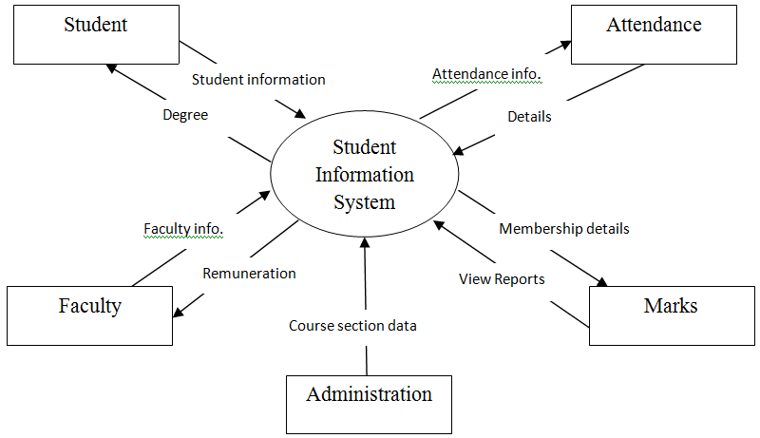
- TABLE STRUCTURE
1. Students Table
Field Name | Data Type | Description
StudentID | AutoNumber | Unique identifier for each student.
FirstName | Text | First name of the student.
LastName | Text | Last name of the student.
DateOfBirth | Date/Time | Date of birth of the student.
Gender | Text | Gender of the student (e.g., Male, Female).
Address | Text | Home address of the student.
Email | Text | Email address of the student.
PhoneNumber | Text | Contact phone number of the student.

2. Courses Table

Field Name | Data Type | Description
CourseID | AutoNumber | Unique identifier for each course.
CourseName | Text | Name of the course.
Department | Text | Department offering the course.
Credits | Number | Number of credits assigned to the course.

3. Enrollments Table

Field Name | Data Type | Description
EnrollmentID | AutoNumber | Unique identifier for each enrollment record.
StudentID | Number | Foreign key referencing the StudentID in Students.
CourseID | Number | Foreign key referencing the CourseID in Courses.
EnrollmentDate | Date/Time | Date when the student enrolled in the course.

- FORMS

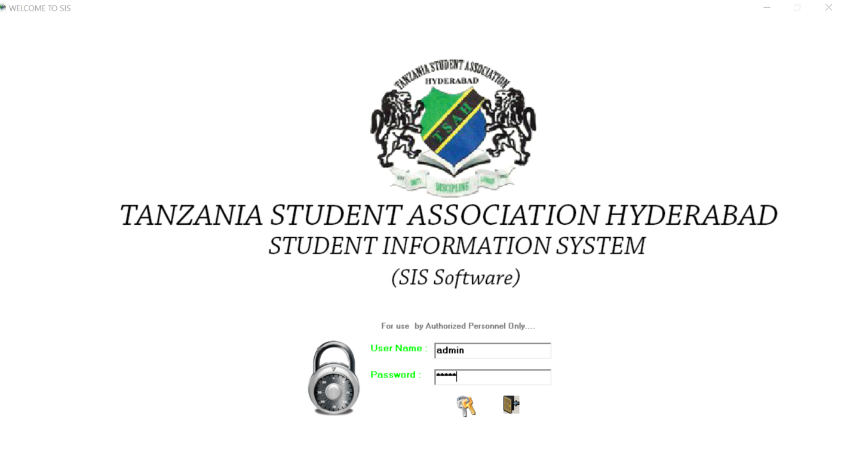
HOME

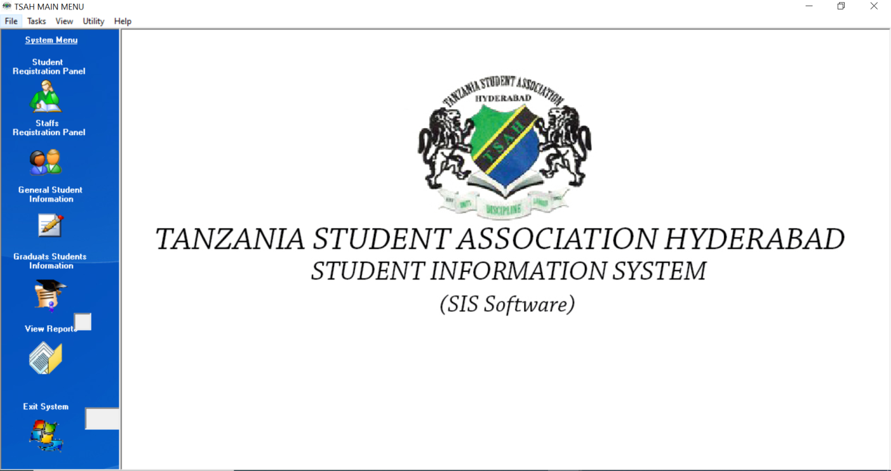
MAIN FORM

STUDENT REGISTRATION

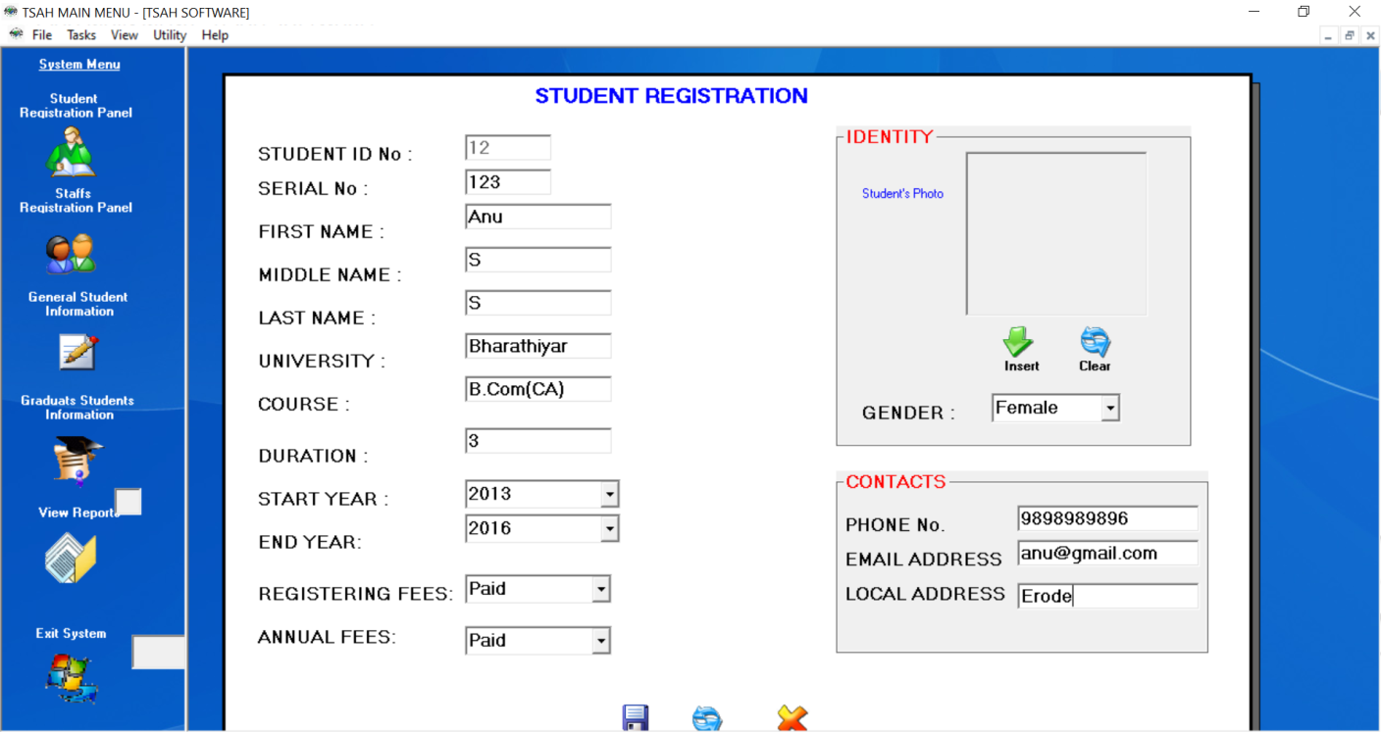

STUDENT GENERAL INFORMATION

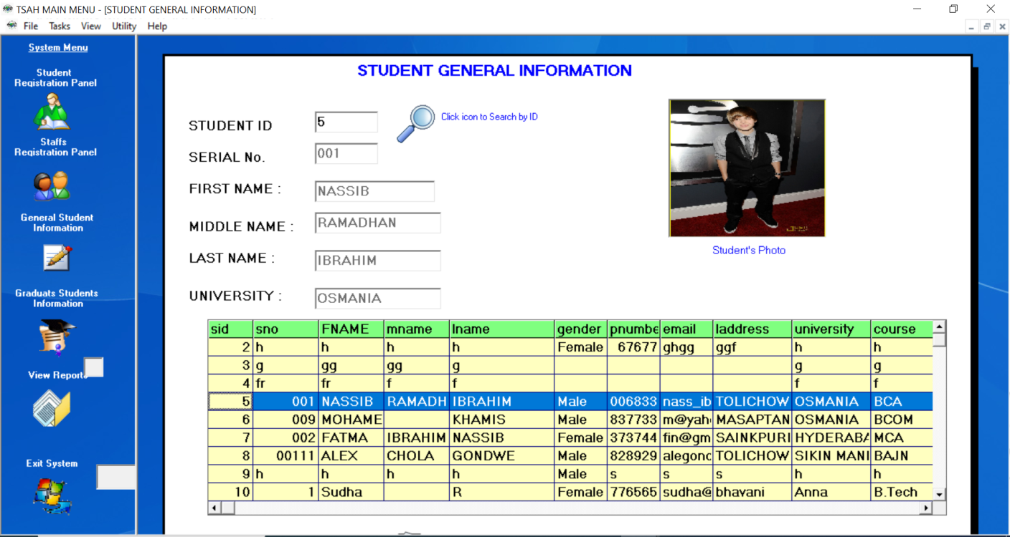

REGISTER STUDENT REPORT

